Reflective summary of the notes

The week one of responsive web application unit explains some basi and imoortan theories of HTML,CSS,GUI and UX, and also completed weekly practicals will be describes with those important basic theories.

HTML ( hypertext markup language )

Web pages are written in HTML, also referred to as HyperText Markup Language. A Web page with text, pictures, sound, and video can be made using HTML.

Tags

Tags are the foundation of HTML programming.

A tag is a keyword that is encased in angle brackets (for instance, "I").

Many tags, but not all, have opening and closing tags; Between the two tags is the text that is impacted.

Narrow Tags

When using HTML tags inside of other HTML tags, the closest tag must always be closed first.

For instance:

<H1> <I> The Nation (I) and (H1)

Formatting Text

• HTML text manipulation can be challenging; frequently, what you see is NOT what you get

what you receive

• To make paragraphs, go to the next line, and create headings, for instance, certain HTML tags are required.

Tags for Text Formatting

Strong Face

Italics

Underline

A fresh paragraph

After Line

Headings

• Sections with headings are frequently used to divide up web pages;

To design a heading use the phrase...

where n is a number in the range of 1 to 6

• In this instance, the 1 represents the heading with the largest size, while the 6

is equivalent to the smallest size

Statements of Comment

• HTML comment statements are notes that explain significant terms in the code.

components of the code

Formatting Text

• HTML text manipulation can be challenging; frequently, what you see is NOT what you get

what you receive

• To make paragraphs and move between them, for instance, certain HTML tags are required.

the next line, and add headers

Tags for Text Formatting

Strong Face

Italics

Underline

A fresh paragraph

After Line

Headings

• Sections with headings are frequently used to divide up web pages;

To design a heading use the phrase...

where n is a number in the range of 1 to 6

• In this instance, the 1 represents the heading with the largest size, while the 6

is equivalent to the smallest size

After this body comes which contains the main aspects of the code and finally have to close the html ( </html>) and end the code.

CSS ( Cascading Style Sheets )

Cascading Style Sheet, or CSS. A text file with an extension is a typical CSS file. css and consists of a number of instructions or rules. These guidelines specify how to show in HTML.

HTML and CSS work together to produce beautiful and functional Web sites

● HTML = structure

● CSS = style

There are 3 ways to attach CSS to a page:

1. External Style Sheet: Best used to control styling on multiple pages.

<link rel="stylesheet" type="text/css" media="all" href="css/styles.css" />

2. Internal Style Sheet: Best used to control styling on one page. <style type=“text/css”> h1 {color: red} </style> Attaching a Style Sheet

3. Inline Style Sheet\*: CSS is not attached in the <header> but is used directly

within HTML tags.

<p style=“color:red”>

Some Text</p>

GUI

The actual buttons, text, and pixels that show up on the screen are referred to as GUI.

Everything that pertains to how a website or application appears in the interface would be the responsibility of the GUI designer. This refers to both the page's graphics and general design. For instance, where should the "Sign Up" button be placed?

UX

Because it covers all the systems and interactions that support the interface in addition to the interface itself, this discipline is more larger and more advanced than GUI. As an illustration, the UX designer should be concerned with both the appearance of pixels on the screen and what occurs when a frustrated user calls the help desk.

Practicals

My-cv

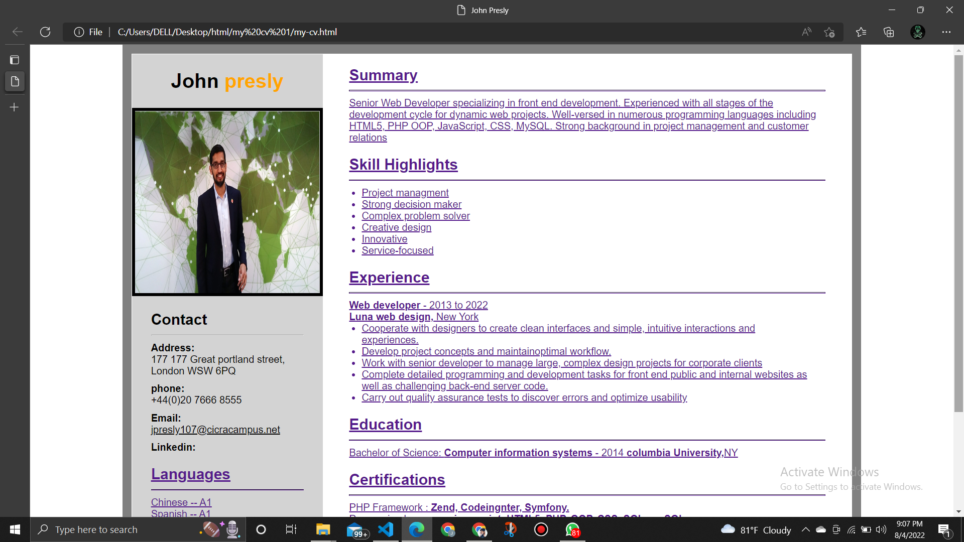  
  
this indicates a well user friendly and responsive web page.

Excercis 2

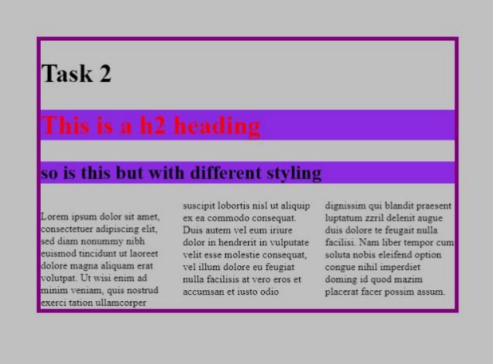

this indicates a well user friendly, responsive web page with headin 2 type.

GITHUB LINK :- <https://github.com/jpcicra/SIT120-RWA-Assignments.git>